**CIS 350 – SUMMER 2021**

**Professor Steiner**

**Demetrius E Johnson**

**Program 3 Documentation**

**22 July, 2021**

1. **Problem Statement**

Create an MST using Prim’s Algorithm given a connected graph providing the MST and the total cost.

1. **Requirements**
   1. **Assumptions**

Input file values will be integers

File FORMAT is correct

Number of vertices and number of edges in input file

Consider correct values if 0 or greater

Negative values are invalid

Negative value for edges – no edges will appear in the input file for this graph

File may contain multiple graphs

Undirected graph

Graph input will be a connected graph even after discarding invalid edges

* 1. **Specifications**

Display message “Welcome to the MST Test Program” to user

Display message “Enter output file name: ” to user

Read and use the user entered output file name

If output file cannot be used

Display message “file <user output file name> cannot be opened – program terminated” to user

Display message “Welcome to the MST Test Program” to output file

Display message “Testing Default Scenario” to user and output file

Create an empty graph and test functionality – No MST

Display message “Testing File Data” to user and output file

Display message “Enter file name for graph data: ” to user

Read user entered input data file name

Display message “File name for graph data: <input file name>” to ouput file

Perform file validation

If cannot open

Display message “file <user input file name> cannot be opened or does not exist – program terminated”

If file exists but is empty

Display message “file <user input file name> contains no data – program terminated”

For each graph in the input file data

Create full graph

Number of vertices and number of edges is first line of each set of graph data

if number of vertices less than zero

display message “ERROR: number of vertices: <number of vertices> is less than zero” to user and output file

display message “Empty Graph Will Be Created” to user and output file

create empty graph

otherwise

if number of vertices is equal to 0

display message “Number of vertices: <number of vertices> is equal to zero” to user and output file

display message “Empty Graph Will Be Created” to user and output file

create empty graph

otherwise vertices value is greater than 0

display message “Number of vertices: <number of vertices> is valid” to user and output file

if number of edges is less than number of vertices - 1 (zero or less - input file will have NO edge data; greater than zero but less than number of vertices – 1 cannot be connected graph)

display message “ERROR: <number of edges> edges invalid to create connected graph” to user and output file

display message “Empty Graph Will Be Created” to user and output file

create empty graph

if number of edges is less than 0

program will treat as zero edges – file will not contain edges

otherwise

display “Graph with <number of vertices> and <number of edges> will be created” to user and output file

create graph with specified number of vertices

Display “Number of input edges to process is: <number of edges>” to user and output file

attempt to add all edges from the input file to the graph

if empty graph edges cannot be added

display message “Empty Graph – Cannot Add Edge: <source>, <destination>, <weight>” to user and output file

if invalid value for vertex (non-existent vertex – negative vertex value, 6 vertices in graph and vertex value is 10)

display message “Invalid Source or Destination Vertex – Cannot Add Edge: <source>, <destination>, <weight> - Edge request ignored” to user and output file

if invalid value for weight (weight must be greater than 0)

display message “Invalid Weight – Cannot Add Edge: <source>, <destination>, <weight> - Edge request ignored” to user and output file

otherwise edge can be added to graph

undirected graph so there are two edges added to graph adjacency list

display message “Edge Added: <source>, <destination>, <weight>” to user and output file

Print the full graph adjacency list

display message “Full Graph – Adjacency List” to user and output file

For each vertex display graph adjacency list to user and output file in format

Adj[vertex] -> (destination1, cost1) (destination2, cost2)

Create the MST

Start with vertex 0

add edges to partial MST until complete (Prim’s algorithm) using a priority queue

Print the MST

display message “Minimum Spanning Tree” to user and output file

if empty graph

display message “Empty Graph – No MST” to user and output file

otherwise

list all edges and weights of the MST

display message “Edge: <nbr> - < connected vertex> weight: <edge weight>” to user and output file

display message “Total cost of MST: <total MST Weight>” to user and output file

display message “MST Graph – Adjacency List” to user and output file

for each vertex display MST adjacency list to user and output file in format

Adj[vertex] -> (destination1, cost1) (destination2, cost2)

Display message “Thank you for running the MST Test Program written by <your name>!” to user and output file

1. **Decomposition Diagram** (Used to break program down into components visually. Can have as many components as needed. Defines functionality that will solve the problem – does NOT define a flow )

Main

* Input
  + User file name
    - File validation
  + File Data
    - File data edits
      * Format:
        + number of vertices, number of edges
        + source vertex, destination vertex, weight
* Process
  + Create graph
  + Create MST
* Output
  + Welcome message
  + Input error messages
  + Print full graph – adjacency list
  + Print MST – edge sequence and adjacency list
  + End message

1. **Test Strategy**

File Testing (exist, empty)

Valid data

Invalid data

1. **Test Plan Version 1**

|  |  |  |  |  |  |  |
| --- | --- | --- | --- | --- | --- | --- |
| Test Strategy | Test Number | Description | Input | Expected Output | Actual Output | Pass/Fail |
| File Testing | 1 | File does not exist |  |  |  |  |
| File Testing | 2 | File exists but empty |  |  |  |  |
| Valid data | 1 | Valid connected graph vertices and edges |  |  |  |  |
| Valid data | 2 | Empty graph |  |  |  |  |
| Invalid data | 1 | Invalid number of vertices |  |  |  |  |
| Invalid data | 2 | Invalid number of edges |  |  |  |  |
| Invalid data | 3 | Invalid edge source vertex |  |  |  |  |
| Invalid data | 4 | Invalid edge destination vertex |  |  |  |  |
| Invalid data | 5 | Invalid edge weight |  |  |  |  |
|  |  |  |  |  |  |  |

1. **Initial Algorithm**

Data: Object Definitions

Struct pqData

Data:

integers: keyWeight, keyDestinationVertex, keySourceVertex

Class edge

Data:

integers: sourceVertex, destinationVertex, edgeWeight

link: nextEdge

Actions:

default constructor: initalize all data to -1

3 paramater constructor: integers source, destination, weight

Assign to appropriate class variables

Class resultSetClass

Data:

integers: parent, weight

Actions:

Default constructor: set all variables to value of -1

Class graph

Data:

integer: numberOfVertices

array of linked lists (must be able to hold all vertices): adjacencyList Graph, adjacencyListMST

Actions:

default constructor:

Set numberOfVertices to zero

display messsage “Default - Empty Graph Created”

1 parameter constructor: integer vertices

Set numberOfVertices to vertices

initialize adjacencyListGraph for each vertex as empty list; points to edge object

addEdge: 3 integer parameters source, destination, weight

if numberOfVertices equals zero

display message “Empty Graph – Cannot Add Edge: <source>,

<destination>, <weight>” to user and output file

otherwise

if either source or destination is less than zero or greater than numberOfVertices

display message “Invalid Source or Destination Vertex – Cannot Add Edge: <source>, <destination>, <weight> - Edge request ignored” to user and output file

if either weight is zero or less

display message “Invalid Weight – Cannot Add Edge: <source>, <destination>, <weight> - Edge request ignored” to user and output file

otherwise edge can be added to graph

create edge object – source, destination, weight

add to source vertex in adjacencyListGraph

display message “Edge Added: <source>, <destination>, <weight>” to user and output file

create edge object – destination, source, weight since undirected graph

add to destination vertex in adjacencyListGraph

display message “Edge Added: <destination>, <source>, <weight>” to user and output file

printGraph – no parameters

display message “Full Graph – Adjacency List” to user and output file

Loop through adjacencyListGraph

For each vertex display to user and output file adjacency list in format:

Adj[vertex] -> (destination1, cost1) (destination2, cost2)

primMST – no parameters

Create pqData extractedPQData

Create pqData intoPQData

Create boolean array mst of size numberOfVertices

Initialize mst values to false

Create resultSetClass array resultSet of size numberOfVertices ) default constructor

Initialize resultSet to point to resultSetClass instances

Create integer array weights of size numberOfVertices

Initialize weights values to maximum integer value (e.g. C++ INT_MAX)

Vertex 0 is starting vertex – create non-edge priority queue entry to start MST

Set weights[0] to zero

Set pqData keyWeight to weights[0]

and keyDestinationVertex to 0

and keySourceVertex to 0

Add pqData to min-heap priority queue (you are to code your own priority queue – you cannot use library methods)

Set resultSet[0].parent to -1 (vertex 0 has no parent)

Loop while priority queue is not empty

Dequeue root from priority queue into extractedPQData – dequeueing minimum edge where keyDestinationVertex is vertex that will be added to the MST

Set mst[extractedPQData.keyDestinationVertex] to true

If extractedPQData.keyDestinationVertex and extractedPQData.keySourceVertes are both zero

skip over – vertex 0 start priority queue entry that is not an edge

otherwise

Add edges to adjacencyListMST for source and destination vertices (since undirected graph) for extractedPQData keySourceVertex and keyDestinationVertex and keyWeight values

Iterate through all the adjacent vertices to newly added vertex and update the weights as needed

For each edge in extractedPQData.keyDestinationVertex adjacency list

If mst[edge.destinationVertex] is equal to false (the destination vertex not in MST)

If weights[edge.destinationVertex] is greater than edge.edgeWeight

Assign edge.edgeWeight, edge.destinationVertex, and edge.sourceVertex to intoPQData keyWeight, keyDestinationVertex, and keySourceVertex

Add intoPQData to priority queue

Update resultSetClass

Set resultSet[edge.destinationVertex]. parent to extractedPQData.keyDestinationVertex

Set resultSet[edge.destinationVertex].weight to edge.edgeWeight

Set weights[edge.destinationVertex] to edge.edgeWeight

printMST – no parameters

Create integer totalMSTWeight, initialize to zero

Display message “Minimum Spanning Tree”

If numberOfVertices equals zero

Display message “Empty Graph – No MST”

Return from method

Loop through resultSet (nbr from 1 to number of vertices - 1)

Display message “Edge: <nbr> - <resultSet[nbr].parent> weight: <resultSet[nbr].weight”

Add resultSet[nbr].weight to totalMSTWeight

Display message “Total cost of MST: <totalMSTWeight>”

Display message “MST Graph – Adjacency List”

Loop through adjacencyListMST

For each vertex display adjacency list in format

Adj[vertex] -> (destination1, cost1) (destination2, cost2)

destructor: deallocate objects in adjacency list

Program: main

Main:

Display message “Welcome to the MST Test Program” to user

Display message “Enter output file name: ” to user

Read user entered output file name

Open output file

If output file cannot be opened

Display message “file <user output file name> cannot be opened – program terminated” to user

Terminate program

Display message “Output file: <user output file name>” to output file

Display message “Testing Default Scenario” to user and output file

Create default graph constructor instance – empty graph

Call method mstPrim – no MST created

Call method printMST – no MST created message

Display message “Testing File Data” to user and output file

Display message “Enter file name for graph data” to user

Read user entered input file name

Display message “File name for graph data: <input file name>” to ouput file

Open file

If file cannot be opened

Display message “File <user file name> cannot be opened or does not exist – program terminated” to user and output file

Terminate program

otherwise

If file opens but has no data in it

Display message “File <user file name> contains no data – program terminated” to user and output file

Terminate program

otherwise file has data to process

Loop until end of file – each loop instance is one graph

Number of vertices and number of edges is first line of each set of graph data

if number of vertices is less than zero

display message “ERROR: number of vertices: <vertices> is less than zero”

display message “Empty Graph Will Be Created”

create graph object with parameter of 0 vertices – empty graph

otherwise

if number of vertices is equal to zero

display message “Number of vertices: <vertices> is equal to zero”

display message “Empty Graph Will Be Created”

create graph object with parameter of 0 vertices – empty graph

otherwise vertices value is greater than zero

display message “Number of vertices: <vertices> is valid”

if number of edges is less than number of vertices - 1 (zero or less - input file will have NO edge data; greater than zero but less than number of vertices – 1 cannot be connected graph)

display message “ERROR: <number of edges> edges invalid to create connected graph” to user and output file

display message “Empty Graph Will Be Created” to user and output file

create graph object with parameter of 0 vertices – empty graph

if number of edges is less than 0

program will treat as zero edges – file will not contain edges

otherwise

display “Graph with <number of vertices> and <number of edges> will be created” to user and output file

create graph object with parameter of number of vertices

Display “Number of input edges to process is: <number of edges>” to user and output file

Loop for second data in the file (number of edges)

Read fileSource, fileDestination, fileWeight

Call addEdge in graph instance

Call printGraph

Call mstPrim

Call printMST

Deallocate graph object

Read from file to see if more graphs

End graph loop

Display message “Thank you for running the MST Test Program written by <your name>!” to user and output file

1. **Test Plan Version 2**

|  |  |  |  |  |  |  |
| --- | --- | --- | --- | --- | --- | --- |
| Test Strategy | Test Number | Description | Input | Expected Output | Actual Output | Pass/Fail |
| File Testing | 1 | File does not exist | File name that does not exist | “File <user file name> cannot be opened or does not exist – program terminated” |  |  |
| File Testing | 2 | File exists but empty | File name that exists but has no data | “File <user file name> contains no data – program terminated” |  |  |
| Valid data | 1 | Valid connected graph vertices and edges | File mst1.dat | MST with cost of 9 |  |  |
| Valid data | 2 | Empty graph – default constructor | Coded in program | “Empty Graph – No MST” |  |  |
| Valid data | 3 | Display messages to user | Coded in program | All messages verified on screen and in output file |  |  |
| Valid data | 4 | Print full graph | File mst2.dat | 2 graph adjacency lists verified |  |  |
| Valid data | 5 | Print MST | File mst2.dat | 2 MST edge lists and adjacency lists and total cost of MSTs verified |  |  |
| Invalid data | 1 | Invalid number of vertices | File mst4.dat | “Empty Graph – No MST” |  |  |
| Invalid data | 2 | Invalid number of edges | File mst4.dat | “Empty Graph – No MST” |  |  |
| Invalid data | 3 | Invalid edge source vertex | File mst3.dat | 3 error edges |  |  |
| Invalid data | 4 | Invalid edge destination vertex | File mst3.dat | 2 error edges |  |  |
| Invalid data | 5 | Invalid edge weight | File mst3.dat | 2 error edges |  |  |
| Invalid data | 6 | Try to add edges to empty graph | File mst4.dat  Graph 0 5 | Graph 0 5 edges cannot add edge error message |  |  |
| Invalid data | 7 | Not enough edges for connected graph | File mst.4  Graph 5 3 | “ERROR: 3 edges invalid to create connected graph” |  |  |

Part 1 ends here!!!!!!

1. **Code**

Copy and paste your code here. MAKE SURE TO COMMENT YOUR CODE!

# MAIN FILE:

// This file contains the 'main' function. Program execution begins and ends there.

//Author: Demetrius E Johnson

//Purpose: create a program that uses a priority queue (using a heap) to implement Prim's aglorithm and effectively execute Minimum Spanning Tree Protocol

//Date Created: 7/14/21

//Date Modified: 7/15/21

#include <iostream>

#include <sstream>

#include<string>

#include <fstream>

#include "graph.h"

using namespace std;

int main()

{

string userInputFile;

string userOutputFile;

cout << "Welcome to the MST Test Program\n";

cout << "Enter output file name: ";

cin >> userOutputFile;

ofstream outputFile(userOutputFile);

//output file not opened sucessfully case:

if (!outputFile.good()) {

cout << "file " << userOutputFile << " cannot be opened – program terminated...\n";

return 1;

}

outputFile << "Welcome to the MST Test Program\n";

outputFile << "Output file: " << userOutputFile << endl;

//Create an empty graph and test functionality – No MST

cout << "Testing Default Scenario...\n";

outputFile << "Testing Default Scenario...\n";

graph emptyGraphTest;

emptyGraphTest.primMST(outputFile);

emptyGraphTest.printMST(outputFile);

cout << "Enter file name for graph data: ";

cin >> userInputFile;

outputFile << "File name for graph data: " << userInputFile << endl;

ifstream inputFile(userInputFile);

//input file not open successfully case:

if (!inputFile.good()) {

cout << "file " << userInputFile << " cannot be opened or does not exist - program terminated...\n";

outputFile << "file " << userInputFile << " cannot be opened or does not exist - program terminated...\n";

system("pause");

return 1;

}

//empty input file case:

while (inputFile.peek() == ' ' || inputFile.peek() == '\n') { inputFile.ignore(); } //ignore leading white spaces and newlines until we reach a char or EOF

if (inputFile.peek() == EOF) {

cout << "file " << userInputFile << " contains no data - program terminated...\n";

outputFile << "file " << userInputFile << " contains no data - program terminated...\n";

system("pause");

return 1;

}

//loop until end of file; each loop instance is one graph:

stringstream ss; //use this to input an integer stored in a string into an int

string lineParse; //use this to parse each line from the input file

int numVertices; //store current numVertices for a graph in the input file

int numEdges; //store current numEdges for a graph in the input file

graph* fileInputGraph; //this is necessary so that each iteration of while loop we can create the proper graph instance

while (inputFile.peek() != EOF) {

cout << endl << endl;

outputFile << endl << endl;

while (inputFile.peek() == ' ' || inputFile.peek() == '\n') { inputFile.ignore(); } //if necessary: ignore leading white spaces / lines before next graph

getline(inputFile, lineParse); //store current line from input file into lineParse

ss << lineParse; //output to stream

ss >> numVertices >> numEdges; //convert char/string to integer values //side note: istream::operator>> only extracts characters; it does not also discard them; use cin.ignore() function to clear buffer if necessary

ss.clear(); //clear stream in case of any bad bits set

//next set of if statements will check number of vertices from the passed in graph:

if (numVertices < 0) {

cout << "ERROR: number of vertices: " << numVertices << " is less than zero\n"

<< "Empty Graph Will Be Created\n";

outputFile << "ERROR: number of vertices: " << numVertices << " is less than zero\n"

<< "Empty Graph Will Be Created\n";

fileInputGraph = new graph(0);

}

else if (numVertices == 0) {

cout << "Number of vertices: " << numVertices << " is equal to zero\n"

<< "Empty Graph Will Be Created\n";

outputFile << "Number of vertices: " << numVertices << " is equal to zero\n"

<< "Empty Graph Will Be Created\n";

fileInputGraph = new graph(0);

}

else {

cout << "Number of vertices: " << numVertices << " is valid\n";

outputFile << "Number of vertices: " << numVertices << " is valid\n";

//next set of if statements will check number of edges from the passed in graph:

if (numEdges < (numVertices - 1) || numEdges < 0) {

cout << "ERROR: number of edges: " << numEdges << " is invalid to create connected graph\n"

<< "Empty Graph Will Be Created\n";

outputFile << "ERROR: number of edges: " << numEdges << " is invalid to create connected graph\n"

<< "Empty Graph Will Be Created\n";

fileInputGraph = new graph(0);

}

else {

cout << "Graph with " << numVertices << " vertices and " << numEdges << " edges will be created\n";

outputFile << "Graph with " << numVertices << " vertices and " << numEdges << " edges will be created\n";

fileInputGraph = new graph(numVertices);

cout << "Number of input edges to process is: " << numEdges << endl;

outputFile << "Number of input edges to process is: " << numEdges << endl;

}

}

//second loop (process all edges given from the file):

for (int i = 0; i < numEdges; i++) {

int fileSource, fileDestination, fileWeight; //use these to store the current edge

getline(inputFile, lineParse); //get current line (edge) which is a string

ss << lineParse; //output string into stringstream for integer conversion on next line

ss >> fileSource >> fileDestination >> fileWeight; //input the values into the appropriate integers

ss.clear(); //clear stream in case of bad bit set; helps with felxibility of input file format

fileInputGraph->addEdge(fileSource, fileDestination, fileWeight, outputFile); //add edge

}

//now call appropriate functions of the graph to create MST and output all results:

fileInputGraph->printGraph(outputFile);

fileInputGraph->primMST(outputFile);

fileInputGraph->printMST(outputFile);

delete fileInputGraph; // end of loop: delete graph; MST and other algorithms already ran; will create new graph at start of loop for next graph if necessary

}//end of while loop

cout << "Thank you for running the MST Test Program written by Demetrius Johnson!\n";

outputFile << "Thank you for running the MST Test Program written by Demetrius Johnson!\n";

//close files

outputFile.close();

inputFile.close();

system("pause");

}

# GRAPH class .H FILE:

#ifndef GRAPH

#define GRAPH

#include <iostream>

#include <fstream>

#include "pqData.h"

#include "resultSetClass.h"

#include "edge.h"

class graph

{

private:

int numberOfVertices;

edge* adjacencyListGraph;

edge* adjacencyListMST;

public:

graph();

graph(int vertices);

void addEdge(int source, int destination, int weight, std::ofstream& outFile);

void printGraph(std::ofstream& outFile);

void primMST(std::ofstream& outFile);

void printMST(std::ofstream& outFile);;

~graph();

};

#endif

# GRAPH class .CPP:

#include "graph.h"

graph::graph() {

numberOfVertices = 0;

adjacencyListGraph = new edge[numberOfVertices];

adjacencyListMST = new edge[numberOfVertices];

std::cout << "Default - Empty Graph Created\n";

}

graph::graph(int vertices) {

numberOfVertices = vertices;

adjacencyListGraph = new edge[numberOfVertices];

adjacencyListMST = new edge[numberOfVertices];

}

//Description: adds an edge to the graph

//Pre-condition: need source, dest, and weight, and also output stream so we can output text to the user output file

//Post-condition: edge will be added to the adjacency array and proper outputs will occur to the screen and user file

void graph::addEdge(int source, int destination, int weight, std::ofstream& outFile) {

//3 if-statements to check if request is valid:

if (numberOfVertices == 0) {

std::cout << "Empty Graph - Cannot Add Edge: " << source << "," << destination << "," << weight << std::endl;

outFile << "Empty Graph - Cannot Add Edge: " << source << "," << destination << "," << weight << std::endl;

return;

}

if (source < 0 || destination < 0 || source > (numberOfVertices - 1) || destination > (numberOfVertices - 1)) {

std::cout << "Invalid Source or Destination Vertex - Cannot Add Edge: " << source << "," << destination << "," << weight

<< " - Edge request ignored" << std::endl;

outFile << "Invalid Source or Destination Vertex - Cannot Add Edge: " << source << "," << destination << "," << weight

<< " - Edge request ignored" << std::endl;

return;

}

if (weight <= 0) {

std::cout << "Invalid Weight - Cannot Add Edge: " << source << "," << destination << "," << weight

<< " - Edge request ignored" << std::endl;

outFile << "Invalid Weight - Cannot Add Edge: " << source << "," << destination << "," << weight

<< " - Edge request ignored" << std::endl;

return;

}

//otherwise add edges (keep in mind that if we reach here, num of vertices != 0 and all other valid checks have been passed):

edge* edgePtr = &adjacencyListGraph[source]; //point to start of list for the given source vertex

while(true) {

if (edgePtr->sourceVertex == -1) {

edgePtr->sourceVertex = source;

edgePtr->destinationVertex = destination;

edgePtr->edgeWeight = weight;

break; //edge added; break from loop

}

if (edgePtr->nextEdge == nullptr) {

edgePtr->nextEdge = new edge(source, destination, weight);

break; //edge added; break from loop

}

edgePtr = edgePtr->nextEdge; //edge already occupied; move to next edge and repeat loop

}

std::cout << "Edge Added: " << source << ", " << destination << ", " << weight << std::endl;

outFile << "Edge Added: " << source << ", " << destination << ", " << weight << std::endl;

//now add the additional edge since graph is undirected (destination, source, same weight):

edgePtr = &adjacencyListGraph[destination]; //point to start of list for the given source vertex

while (true) {

if (edgePtr->sourceVertex == -1) {

edgePtr->sourceVertex = destination; //notice how destination and source are reversed

edgePtr->destinationVertex = source;

edgePtr->edgeWeight = weight;

break; //edge added; break from loop

}

if (edgePtr->nextEdge == nullptr) {

edgePtr->nextEdge = new edge(destination, source, weight);

break; //edge added; break from loop

}

edgePtr = edgePtr->nextEdge; //edge already occupied; move to next edge and repeat loop

}

std::cout << "Edge Added: " << destination << ", " << source << ", " << weight << std::endl;

outFile << "Edge Added: " << destination << ", " << source << ", " << weight << std::endl;

}

//Description: will print the adjacency list for the graph

//Pre-condition: graph must be a valid graph

//Post-condition: output adjacency list for the undirected graph

void graph::printGraph(std::ofstream& outFile) {

std::cout << "Full Graph - Adjacency List: \n";

outFile << "Full Graph - Adjacency List: \n";

edge* edgePtr; //use this pointer to navigate through linked list

for (int i = 0; i < numberOfVertices; i++) {

edgePtr = &adjacencyListGraph[i]; //set edge ptr to the current corresponding vertex

std::cout << "Adj[" << i << "]-> "; //print adjacency messages for the current vertex

outFile << "Adj[" << i << "]-> ";

while (edgePtr != nullptr && edgePtr->sourceVertex != -1) {

std::cout << "(" << edgePtr->destinationVertex << "," << edgePtr->edgeWeight << ")";

outFile << "(" << edgePtr->destinationVertex << "," << edgePtr->edgeWeight << ")";

edgePtr = edgePtr->nextEdge; //move to next edge in the adjacency list for the given vertex

}

std::cout << std::endl;

outFile << std::endl;

}

}

//Description: primes the MST (builds MST) using a priority queue implemented as a heap

//Pre-condition: must have a valid graph

//Post-condition: MST will be built and stored in the proper adjacency array

void graph::primMST(std::ofstream& outFile) {

pqData extractedPQData, intoPQData;

bool* mst;

mst = new bool[numberOfVertices] {false};

resultSetClass* resultSet;

resultSet = new resultSetClass[numberOfVertices];

int* weights;

weights = new int[numberOfVertices] {INT_MAX};

}

//Description: print adjacency list of MST and other information to screen and the output file

//Pre-condition: must have a valid graph

//Post-condition: MST adjacency list and MST value will be printed to user screen and output file

void graph::printMST(std::ofstream& outFile) {}

graph::~graph() {

//deallocate dynamically allocated memory from constructor

delete[] adjacencyListGraph;

delete[] adjacencyListMST;

}

# RESULTSETCLASS H FILE:

#ifndef RESULTSETCLASS

#define RESULTSETCLASS

class resultSetClass

{

private:

int parent;

int weight;

public:

resultSetClass();

};

#endif

# Result set class cpp file:

#include "resultSetClass.h"

resultSetClass::resultSetClass() {

parent = -1;

weight = -1;

}

# Edge class .H file:

#ifndef EDGE

#define EDGE

class edge

{

private:

int sourceVertex;

int destinationVertex;

int edgeWeight;

edge* nextEdge;

friend class graph; //make graph a friend of edge so that graph can access the private members of this class

public:

edge(); //default constructor

edge(int source, int destination, int weight);

};

#endif

# Edge class .CPP file:

#include "edge.h"

edge::edge() {

sourceVertex = -1;

destinationVertex = -1;

edgeWeight = -1;

nextEdge = nullptr;

}

edge::edge(int source, int destination, int weight) {

sourceVertex = source;

destinationVertex = destination;

edgeWeight = weight;

nextEdge = nullptr;

}

# PQ DATA .H FILE:

#ifndef PQDATA

#define PQDATA

struct pqData

{

int keyWeight;

int keyDestinationVertex;

int keySourceVertex;

};

#endif

1. **Updated Algorithm**

Copy and paste Initial Algorithm and make any updates to reflect the changes you made in your code. HIGHLIGHT THE CHANGES YOU MAKE! Strike out deleted statements. Any statements that just have a wording change – make change and highlight (i.e. no need to strike out individual word changes). This is the FINAL documentation of your program and needs to match what code you created.

1. **Test Plan Version 3**

|  |  |  |  |  |  |  |
| --- | --- | --- | --- | --- | --- | --- |
| Test Strategy | Test Number | Description | Input | Expected Output | Actual Output | Pass/Fail |
| File Testing | 1 | File does not exist | File name that does not exist | “File <user file name> cannot be opened or does not exist – program terminated” | See screenshot | pass |
| File Testing | 2 | File exists but empty | File name that exists but has no data | “File <user file name> contains no data – program terminated” | See screenshot | pass |
| Valid data | 3 | Valid connected graph vertices and edges | File mst1.dat | MST with cost of 9 | See screenshot | pass |
| Valid data | 4 | Empty graph – default constructor | Coded in program | “Empty Graph – No MST” | See screenshot | pass |
| Valid data | 5 | Display messages to user | Coded in program | All messages verified on screen and in output file | See screenshot | pass |
| Valid data | 6 | Print full graph | File mst2.dat | 2 graph adjacency lists verified | See screenshot | pass |
| Valid data | 7 | Print MST | File mst2.dat | 2 MST edge lists and adjacency lists and total cost of MSTs verified | See screenshot | pass |
| Invalid data | 8 | Invalid number of vertices | File mst4.dat | “Empty Graph – No MST” | See screenshot | pass |
| Invalid data | 9 | Invalid number of edges | File mst4.dat | “Empty Graph – No MST” | See screenshot | pass |
| Invalid data | 10 | Invalid edge source vertex | File mst3.dat | 3 error edges | See screenshot | pass |
| Invalid data | 11 | Invalid edge destination vertex | File mst3.dat | 2 error edges | See screenshot | pass |
| Invalid data | 12 | Invalid edge weight | File mst3.dat | 2 error edges | See screenshot | pass |
| Invalid data | 13 | Try to add edges to empty graph | File mst4.dat  Graph 0 5 | Graph 0 5 edges cannot add edge error message | See screenshot | pass |
| Invalid data | 14 | Not enough edges for connected graph | File mst.4  Graph 5 3 | “ERROR: 3 edges invalid to create connected graph” | See screenshot | pass |

1. **Screenshots**

TEST 3, 4 – valid data and default empty graph created, and show output messages

MST1.dat :

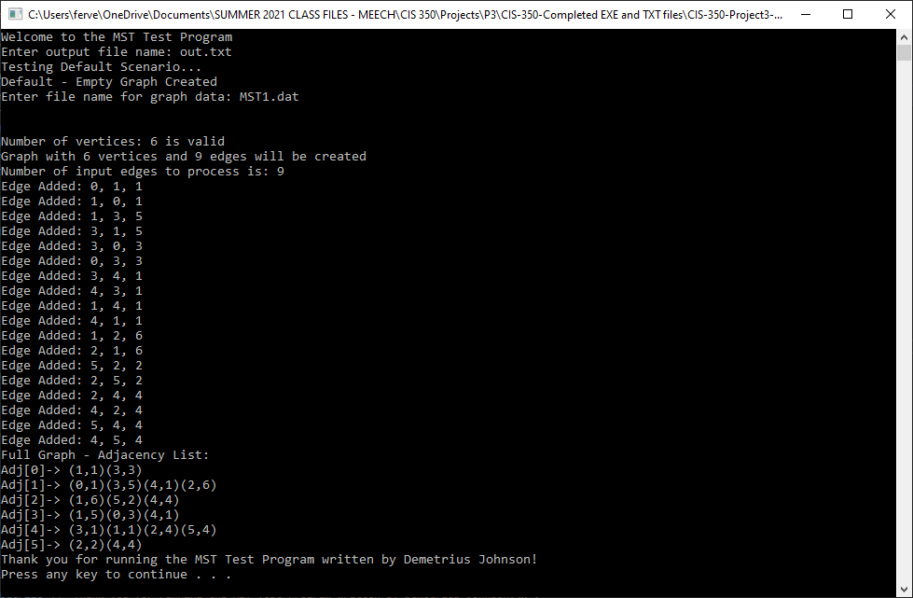

TEST 6, 7 – valid data; multiple graphs

MST2.dat:

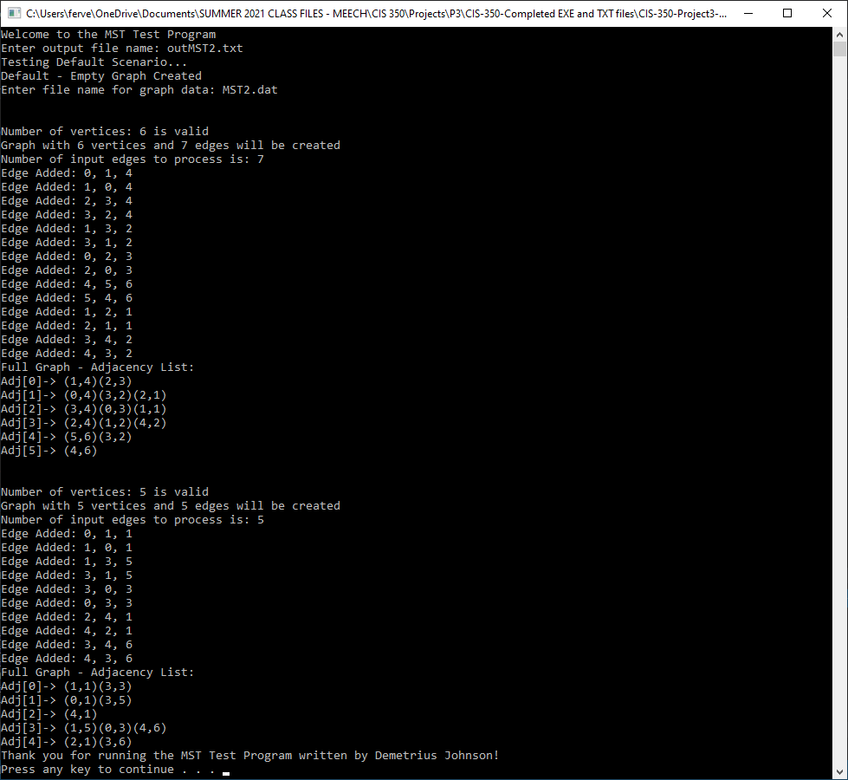

TEST 10, 11, 12 – large graph with valid edges and vertices, but also some invalid edges to add and be ignored

MST3.dat:

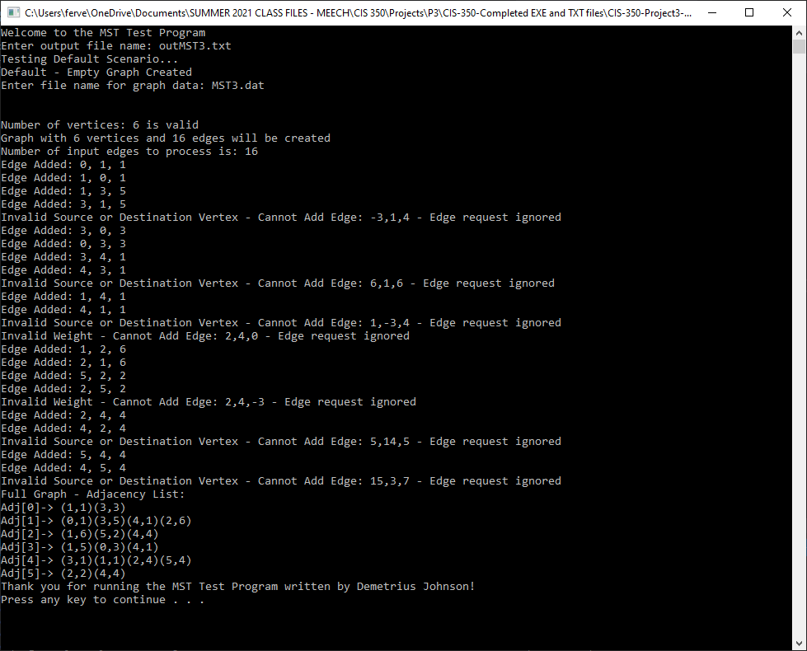

TEST 8, 9, 13, 14 – testing graphs with 0 vertices or edges, invalid number of edges compared to vertices, and invalid vertex number

MST4.dat:

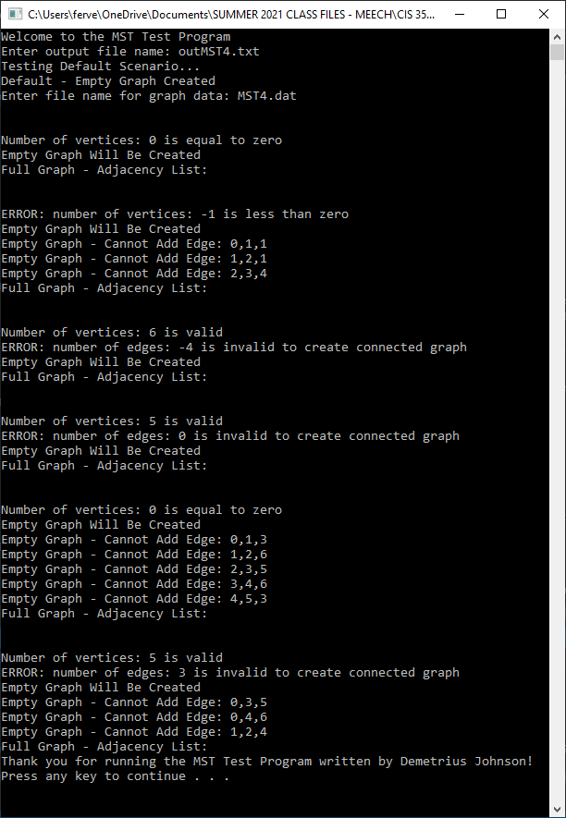

TEST 1 – file does not exist

Invalid output file name:

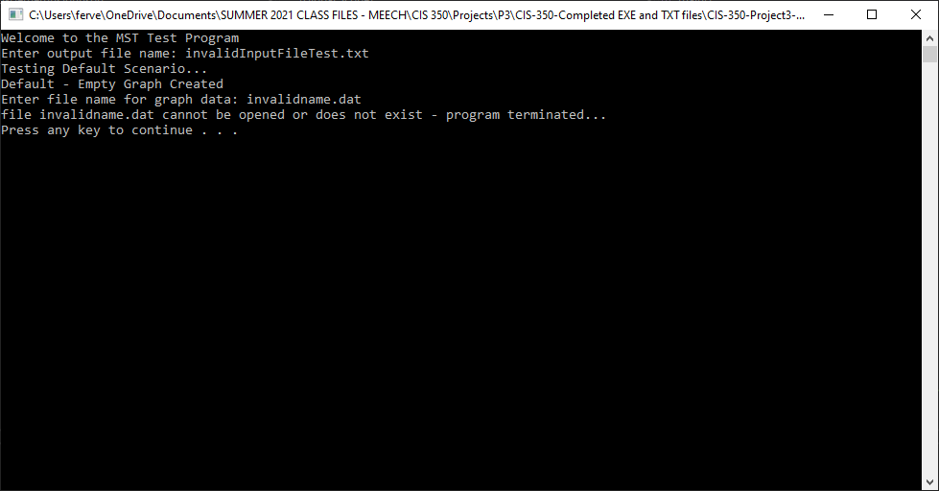

TEST 2 – file exists but is empty:

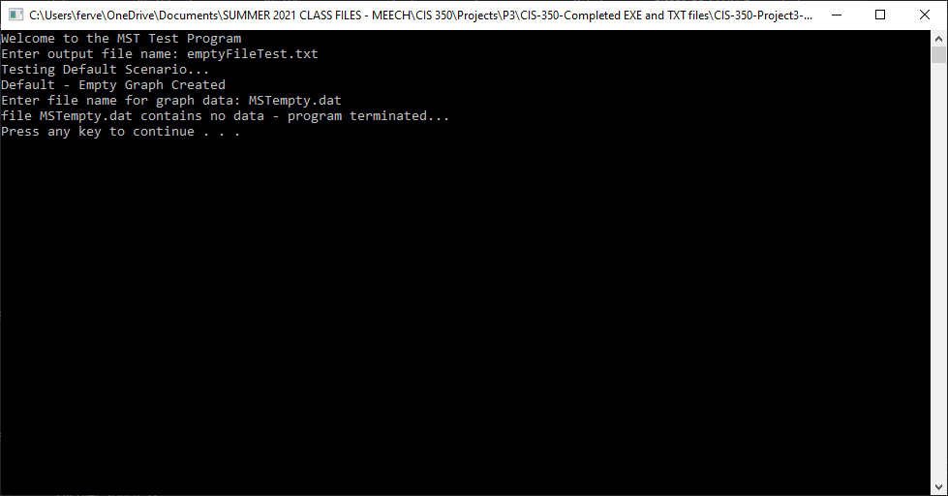

1. **Error Log**

Any issues you had while testing your code are recorded in the error log as you perform testing of the “completed” code – that is, when you run through all of the test cases in the test plan.

|  |  |  |
| --- | --- | --- |
| Error Type | Cause of Error | Solution to Error |
| Log 2 types of errors:  Logic  Runtime | What specifically caused the error to occur | What did you do/change to fix the error |
| Logic error | Told program to do cin.ignore; caused infinite loop | Meant to do inputfile.ignore() |

Do not list any syntax errors or errors detected in unit testing as you build your program.

1. **Status**

Status is incomplete: I was able to do everything but make the priority queue and thus primMST and printMST functions were not completed. Everything else was completed and works fine. Just a matter of the time table, I should be able to complete the rest by this Saturday, July 24 and have 100% completion. Other than that, the rest of the program works exactly up to specification.